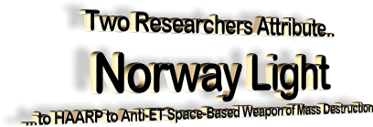

by **Alfred Lambremont Webre**  
**Seattle Exo-politics Examiner**

**December 12, 2010**

**from Examiner Website**

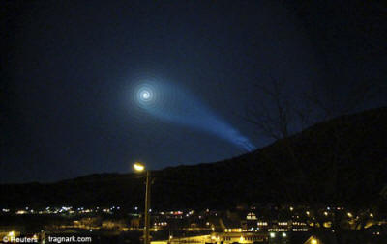

**AP: Nov. 9, 09 spiral light at Tromso, Norway**

Following a cross-volley of interpretations of the Dec. 9, 2009 blue-green light vortex over Norway on the eve of Barack Obama’s Nobel Prize acceptance speech (Russian missile; ETs destroying Russian missile), two researchers have independently posited that HAARP, a space-based weapon of mass destruction one of whose antenna fields is close to the site of the Norwegian spiral light.   
  
According to one of the researchers, D. Wilcock, one of his *confidential sources* stated the Norway spiral light was part of Project Blue Beam.

One of the alleged purposes of *Project Blue Beam* is the use of advanced electromagnetic imaging such as that produced by HAARP and exhibited in the Norway spiral light as a psychological mass conditioning device in aid of the implementation of a global corporate new world order.  
  
If this analysis is accurate, the Norwegian light may have been a HAARP-induced effect attempting to anchor an extraterrestrial-like or “transcendent” aura around U.S. President Barack Obama’s Nobel Prize acceptance speech in Oslo the following day, Nov. 10.

**HAARP and the Norwegian spiral light**

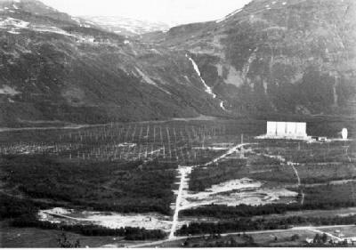

**EISCAT**

**HAARP antenna site near Tromso, Norway**

*According to Mr. Wilcock*, the Dec. 9, 09 Norway spiral light is similar to other spiral lights in Russia in 2006, and in China (first seen in April 2009) that may be attributed to the HAARP technology.  
  
He states that the plasma effects exhibited by the Norway light were too dense to have been produced by a failed Russian missile. He reiterates that HAARP is most probably the cause of the spiral lights.  
  
Researcher Richard Hoagland notes that,

“just over the hill from Tromso [where the spiral light appeared], lies a high-tech Norwegian ‘HAARP antenna farm’ - the EISCAT Ramfjordmoen facility - specifically designed to broadcast powerful beams of microwave energy high into space... thereby also creating blatant HD/torsion side-effects in the Earth's highly-electrified upper "plasma" atmosphere (ionosphere)?

The facility is officially supported by Norway, Sweden, Finland, Japan... China... the United Kingdom... and Germany.”

Although Mr. Hoagland in his analysis implies that the Norway light may have been a warning to President Barack Obama by the controllers of HAARP, the more likely scenario is that Mr. *Obama now works in collaboration with the controllers of HAARP* to use HAARP in the service of the implementation of a corporate new world order worldwide.

**HAARP as a space-based weapon of mass destruction**

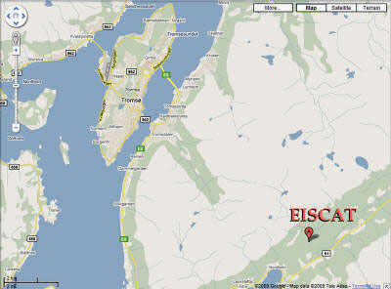

**EISCAT**

**Norway torsion map**

HAARP is an exotic weapons system that is part of the weaponization of space, using "scalar wave interferometry" - a technology first discovered by scientist Nicola Tesla in the early 1900's.

Two or more longitudinal, ultra-low frequency waves are “aimed” at an intersecting point, at which time they interact in a very unique way, “tapping” into the limitless plenum of energy surrounding the planet, and weaponizing this scalar energy.  
  
HAARP has 3 major weapons-system components:

* Space-based component: HAARP weaponizes the Earth's Ionosphere.
* Air-based component: HAARP uses chemtrails as a frequency reflector from its ground and space base, and as a binary weapons system against the human population.
* Ground-based component: HAARP ground stations energize HAARP (Alaska; Greenland; Norway; Australia)

HAARP has numerous reported applications as a weapons system:

* SDI (Strategic Defense Initiative) Radiofrequency weapon
* Environmental warfare - Weather & earthquake warfare
* Space Warfare System
* Missile Defense System
* Scalar energy warfare against land and population targets, including cities, industrial sites, buildings, populations and individuals
* ELF weapon with electromagnetic harassment and mood manipulation of target populations and individuals
* Biological & binary weapons against populations (with chemtrails component)
* Psyops electromagnetic imagery integrated with Project Blue Beam

HAARP is a space-based weapon of mass destruction.

The death toll of two recent probable Environmental Warfare attacks by HAARP is on the scale of Hiroshima.

* The estimated death toll of the May 3, 2008 Weather Warfare Myanmar Cyclone is 78,000 dead + 56,000 missing as of May 29, 2008.
* The death toll of the May 12, 2008 Tectonic Warfare China Earthquake is 68,000 as of May 29, 2008, and expected to rise to 80,000.

Official Japanese figures at the time put the Hiroshima death toll at 118,661 civilians.

But later estimates suggest the final toll was about 140,000.